Schematic

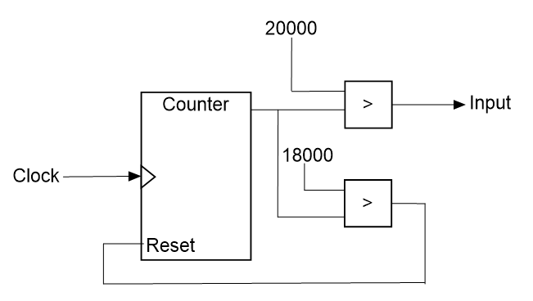

Block Diagram

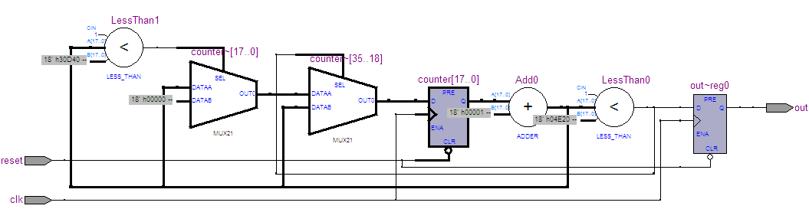

Test Bench

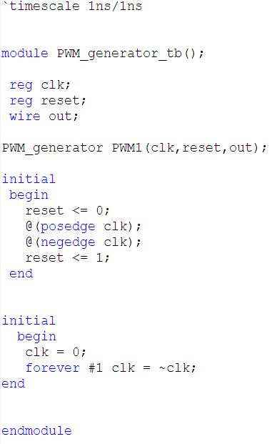

Waveform

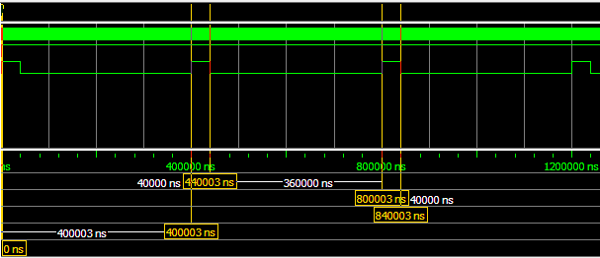

|  |  |  |  |
| --- | --- | --- | --- |
| State | Calculation | Result | Percentage |
| LOW | 800003 ns - 440003 ns | 360000 ns | 90% |
| HIGH | 840003 ns - 800003 ns | 40000 ns | 10% |

Characteristics

|  |  |  |
| --- | --- | --- |
| Parameter | Quantity | unit |
| Total Logic Elements | 46 |  |
| * Total combination function | 47 |  |
| * Dedicated Logic Register | 19 |  |
|  | | |
| Total Thermal Power Dissipation | 67.01 | mW |
| * Core Static Thermal Power Dissipation | 47.35 | mW |
| * I/O Thermal Power Dissipation | 19.66 | mW |
|  | | |
| Timing Analysis |  |  |
| * Clock | 125.00 | MHz |
| * Fmax | 161.21 | MHz |
| * Setup Time |  |  |
| * Hold Time |  |  |